**Cognitive Computing Project Documentation**

**Topic: Name State Classifier**

**Guide:**

Priya Saha

**Presenters:**

Jyothin Movva (2010030071)

Satyavarsan KS (2010030151)

Haneesh Malepati (2010030323)

Devaraj Acharya (2010030040)

Vinay Kumar (2010030469)

**Introduction:**

The number of variants in personal names varies greatly from state to state. With the help of automated feature extraction, we are developing a machine learning model that predicts the states of each name.

To learn more about how characters are structured for naming, we consider exploring personal names. Contrary to other proper nouns like corporate names or acronyms, human names have far more traditional structures. When the names are limited to a single state, these structures become more comprehensible. We have names that are labelled with the states the user names belong to using a dataset that is collected from. We are developing a model to accomplish the same objective.

**Objective:**

* The main objective of this project is to find the state when the name is given as input.

**Flowchart:**

Main Flowchart:

Vector Dataset:

**GitHub Repository:**

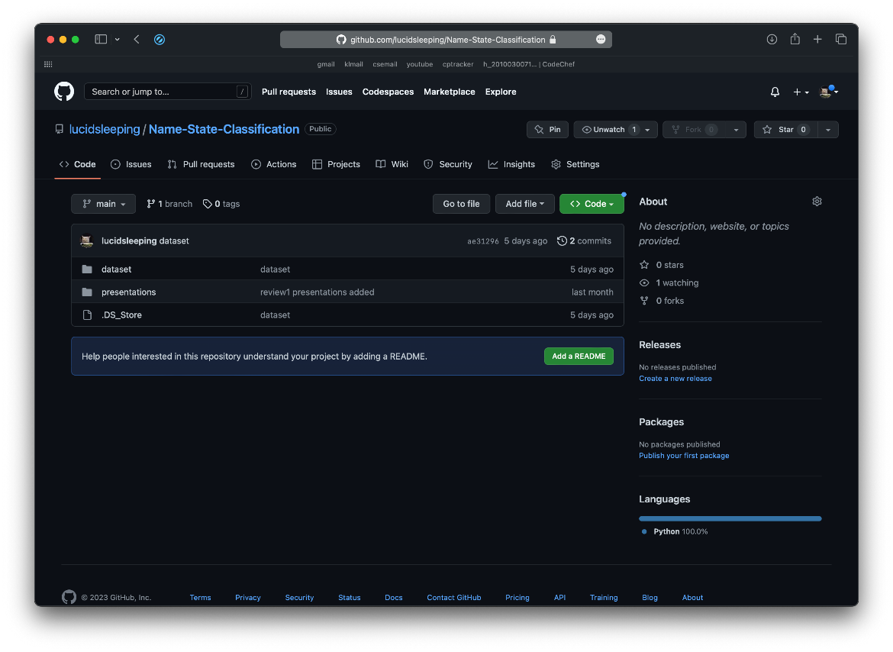

**GitHub Commits:**

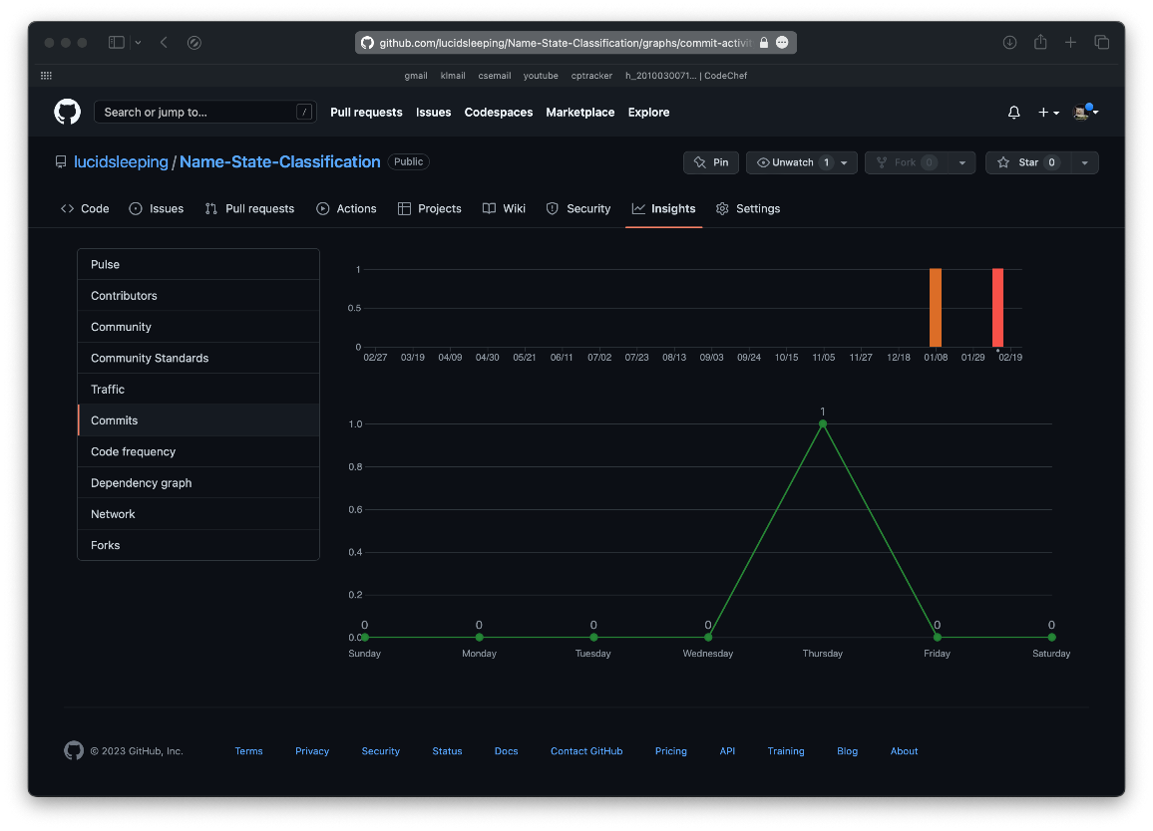

**Code Screenshots:**

Data Normalization:

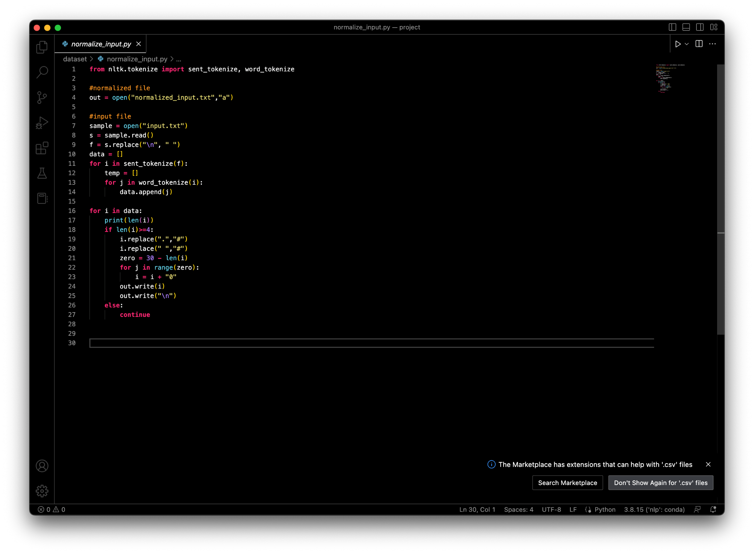

**Normalized Data :**

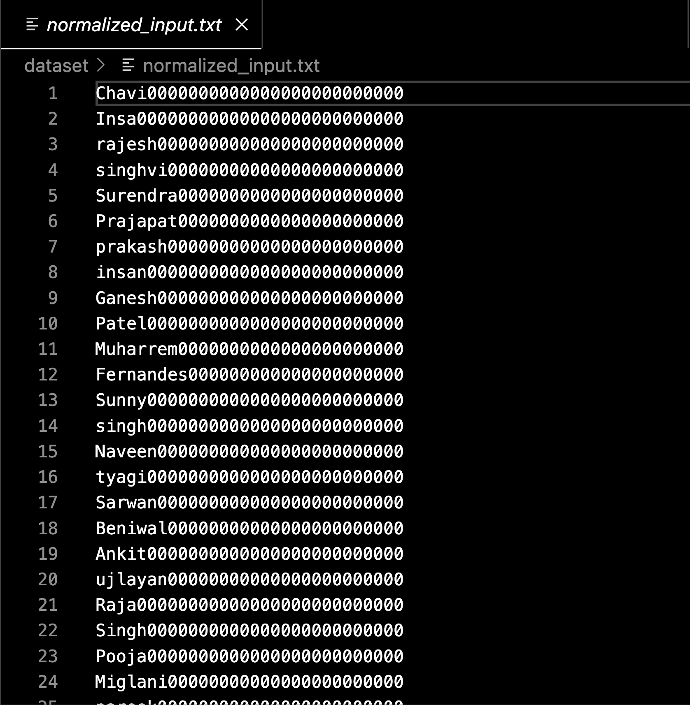

Dataset creation:

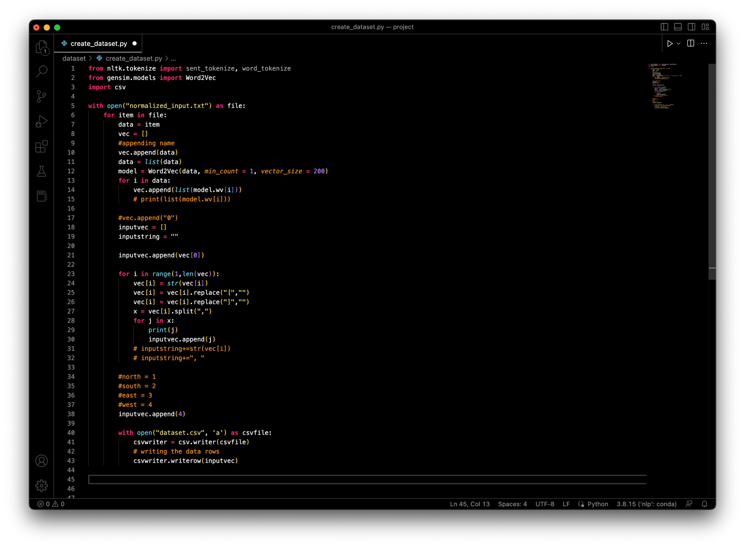

**Code for different models:**

Adaboost:

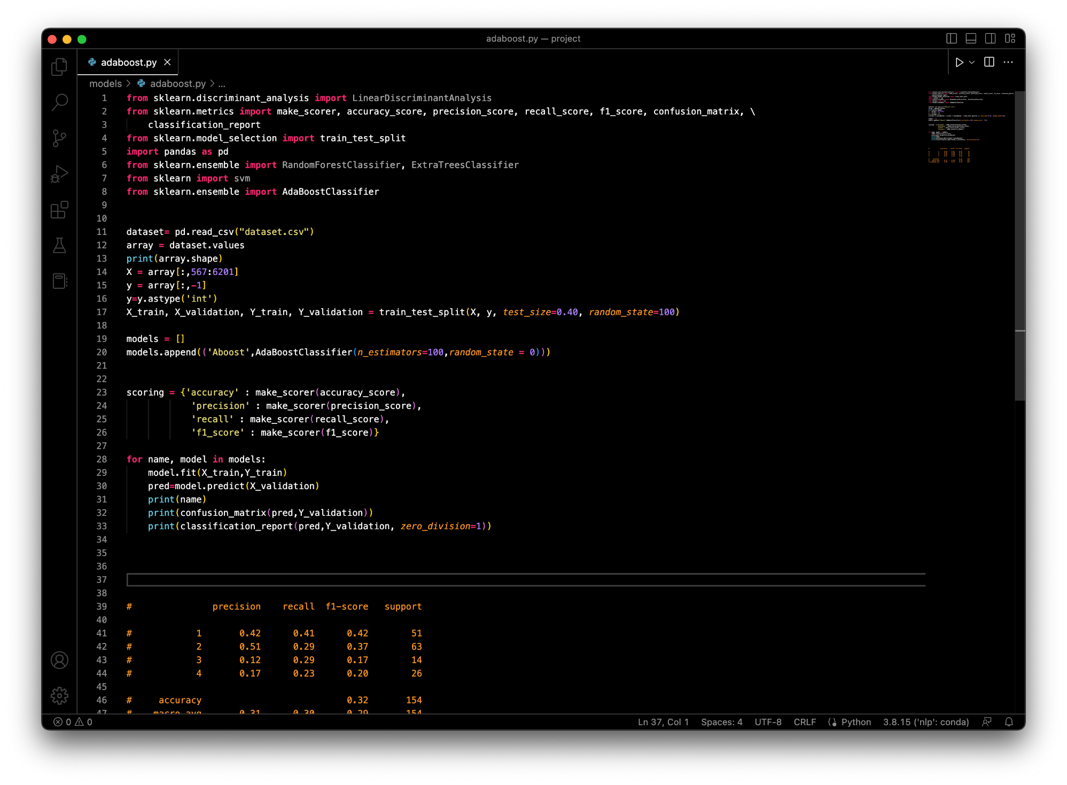

Linear Discriminant Analysis:

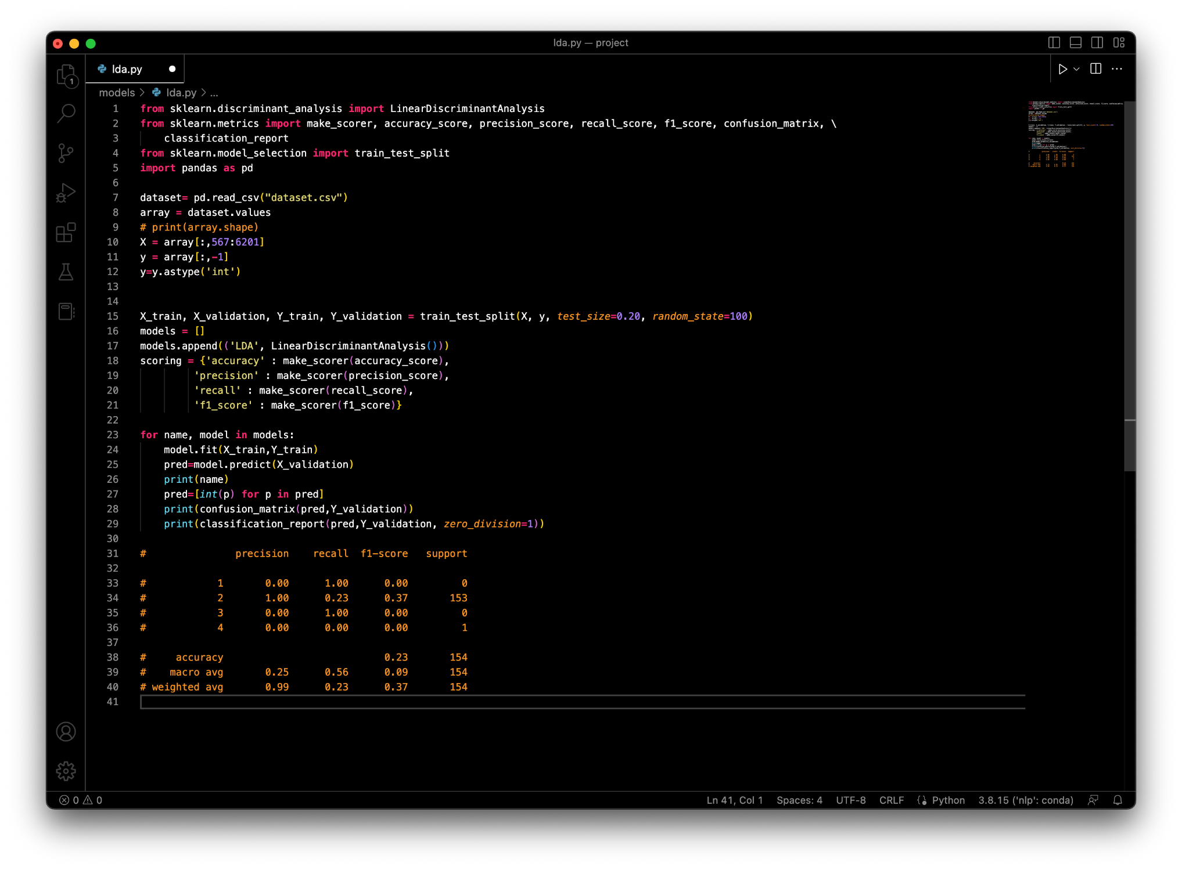

Random Forest:

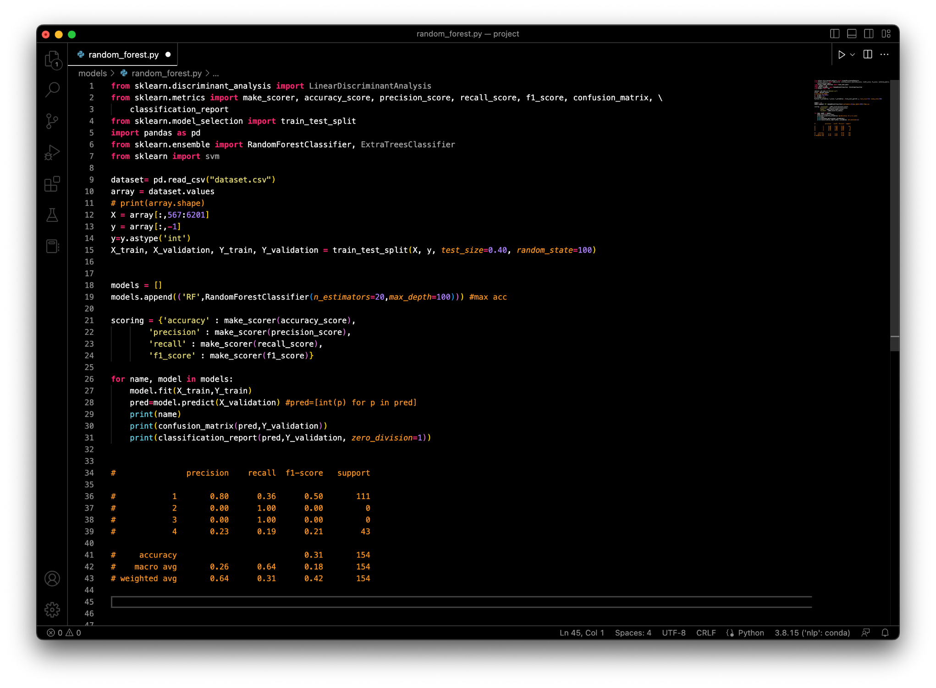

Support Vector Machine:

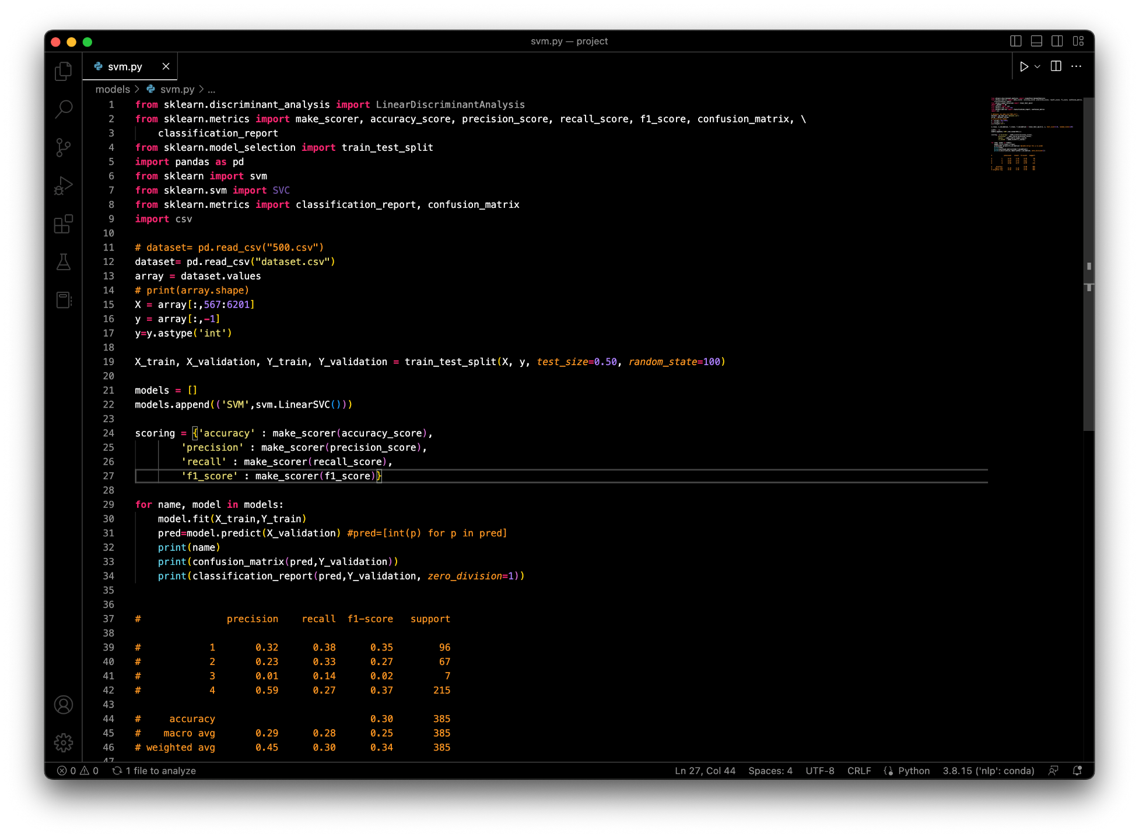

**Dataset:**

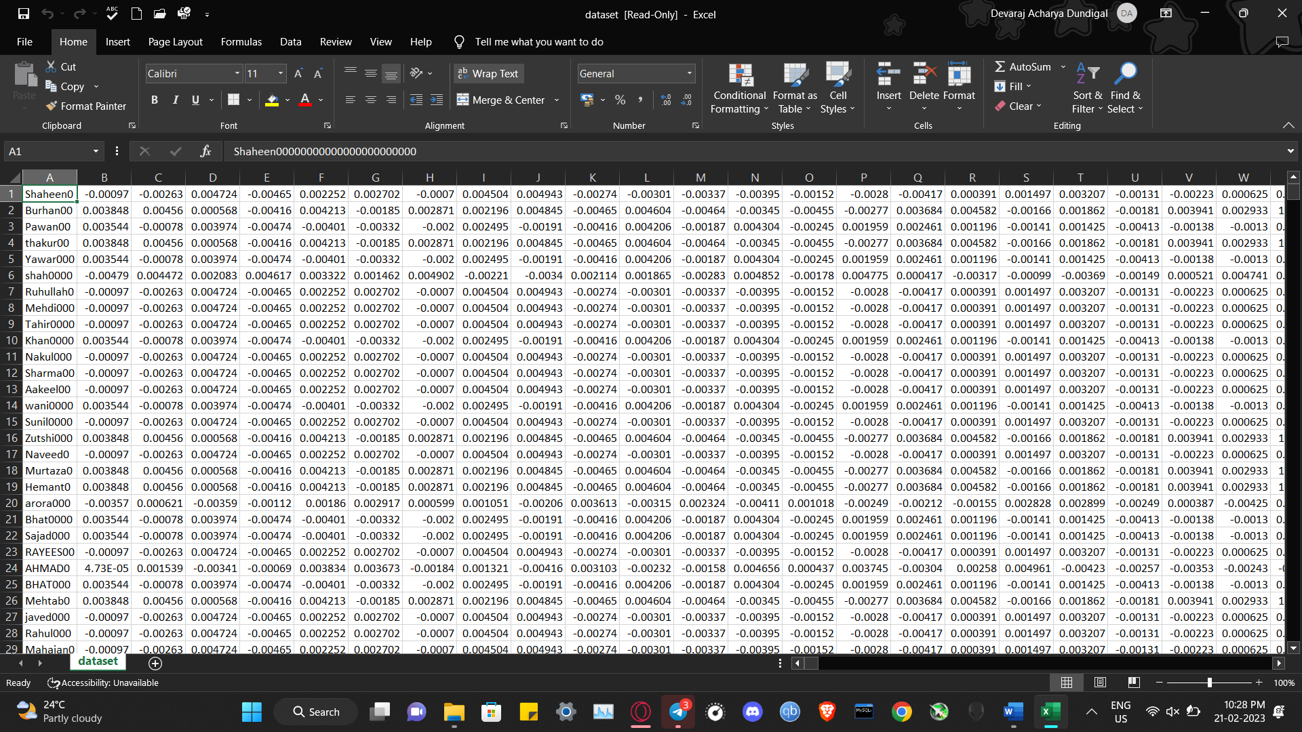

**Model Results:**

